1)Create a project in JMeter and name it FinalProject_HRM

2)Add a ThreadGroup to the created Project for performing actions. Add user count as 20 and the time between them is 5secs.

3)Add the login page to perform testing. Mention the url and its path.

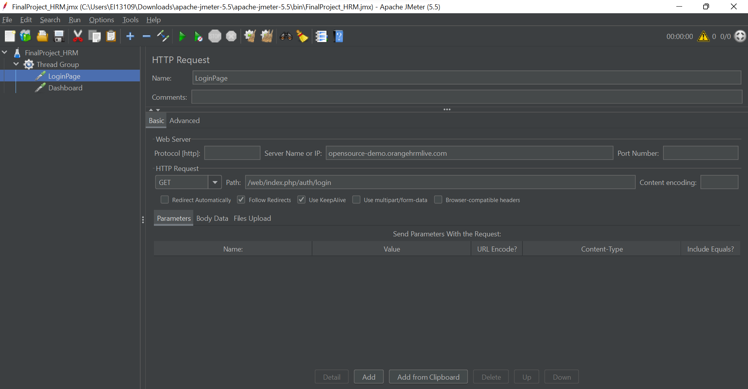

4) Add the dashboard page to perform testing. Mention the url and its path.

5)Add the View results in table field to view the result

6) Add the View results tree field to view the result

7) Add the Aggregate report field to view the result in table format

8)Add response assertion in login page to check whether the Result is correct

9)Add response assertion in Dashboard to check whether the Result is correct

